## BRAC-FSM (ABR)

**Objectives, Guiding principles, Flow Chart, User Guidelines & Carefulness.**

## OBJECTIVE:

The main objective of implementing FSM (Faecal Sludge Management) in the camps is to ensure the preservation and promotion of public health by minimizing the transmission of fecal-related diseases. This objective is achieved by reducing direct exposure to fecal sludge, mitigating the impact of disease- carrying vectors, and preventing environmental contamination.

Furthermore, the ultimate goal of any FSM intervention is to comply with the national effluent standards set by the Government of the People's Republic of Bangladesh, specifically the Standards for Sewage

Discharge as outlined in the Environment Conservation Rules of 1997 and the Bangladesh Standards and Guidelines for Sludge Management (February 2015). These standards, detailed in Appendix C, serve as

the benchmark for ensuring safe and environmentally sound disposal of effluents. Additionally, in 2017, the Department of Environment (DoE) revised these standards, which will come into effect in 2019, and are also provided in Appendix A for reference.

**GUIDING PRINCIPLES:**

To achieve the objective, it is crucial to implement comprehensive full-chain FSM approaches based on the key principles outlined by the WASH Sector in Cox's Bazar:

1. Effective separation: Ensure that untreated faecal sludge is kept separate from people, food, disease vectors, and surface water sources.
2. Universal access: Provide all sections of the community with safe, culturally acceptable, and hygienic latrines. Engage the community to ensure proper operation and maintenance of the latrines.
3. Appropriate latrine design: Design latrines that meet approved standards and minimize the need for sludge handling, such as frequent emptying.
4. Regular emptying: Prevent direct contact with faecal sludge by ensuring regular emptying of full pits.
5. Safe transport: Minimize direct contact and spillage during the transportation of faecal sludge by implementing mechanical transport systems instead of manual methods.
6. Treatment and discharge: Treat and dispose of faecal sludge in a manner that minimizes direct human exposure, reduces the impact of disease vectors, and prevents contamination of surface water bodies.
7. Health and safety measures: Provide proper protective equipment to everyone involved in handling faecal sludge to safeguard their health and safety. Additionally, ensure access to facilities for cleaning and disinfection.
8. Resource utilization: Whenever possible, utilize treated sludge for agricultural purposes, filling material, or as a resource for brick production. However, note that lime-treated sludge may not be suitable for these purposes.

By implementing these principles, the full-chain FSM approaches contribute to achieving the objective of minimizing fecal disease transmission and protecting public health effectively.

Anaerobic Baffle Reactor (ABR- 4 Nos)

Polishing Pond

Filter Chamber (3 Nos)

Soak Pit

Drying Bed

Used the Improve quality of effluent

Soak Pit (1 Nos)

Reduce Watery pathogenic bacteria, Nutrients, BOD &COD.

To Increase the flow of water

Settle Down of Sludge

## Flow Chart:

Settler 1 &2

10000 Liter Sludge Tank

For Continuous Flow to the ABR.

**User Guidelines: Design Concept:**

Ensure that all latrines are constructed in accordance with the agreed latrine designs of RRRC (Refugee Relief and Repatriation Commissioner) and the WASH Sector.

Storage Tank:

Install a 10,000L sludge storage tank equipped with an adjustable gate valve to facilitate a consistent flow of 10,000L wastewater over a 24-hour period. Adjust the gate valve correctly to maintain a maximum flow rate of 333L wastewater per hour or 5.56L wastewater per minute.

Sedimentation Tank:

The sedimentation tank is responsible for reducing the velocity of sewage, allowing suspended matter to settle as sludge. Periodically inspect the sedimentation tank and measure the thickness of the sludge

layer to determine the need for desludging. It is recommended to pump out the sludge from the sedimentation tank:

* When the sludge and scum fill half or two-thirds of the tank's working capacity (volume below the outlet pipe invert level).
* Every 6 months to ensure the proper functionality of the sedimentation tank.

Baffle Chamber:

The baffle chamber is a series of interconnected chambers where wastewater flows upstream. Within these chambers, suspended and dissolved solids in the pre-settled wastewater undergo anaerobic

degradation. The activated sludge settles at the bottom of each chamber, creating a sludge blanket through which the influent wastewater passes. Here, anaerobic bacteria utilize pollutants for their

metabolism. The extended contact time with the active biomass (sludge) leads to improved wastewater treatment. Regular inspections should be conducted to assess the sludge layer thickness and determine the need for desludging. Sludge from the baffle chambers should be pumped out under the following conditions:

* When the bottom of the scum mat is less than 8 centimeters (cm) above the bottom of the baffle/outlet pipe.
* When the minimum working capacity is reached.
* Every 6 months to ensure proper functionality of the baffle chambers.

Filter Media:

Gravel filters are suitable for wastewater with low levels of suspended solids that have already

undergone pre-treatment. These filters employ biological conversion, physical filtration, and chemical adsorption as treatment mechanisms. Horizontal gravel filters (HGFs) have a 1% bottom slope, and water primarily flows horizontally. The filter remains constantly saturated, operating in partially aerobic, partially anoxic, and partially anaerobic conditions. Adding Canna Indica plants to the filter bed enhances treatment by naturally absorbing pollutants. Taller varieties of Canna Indica should be planted 2 feet apart, while dwarf varieties should be planted 1 foot apart, allowing sufficient space for growth while

placing the roots 4 inches deep into the bed to ensure an adequate oxygen supply to the root zone. Once every 12 months, the stone chips in the 1st and 2nd chambers should be thoroughly washed before

reuse, and the coarse sand in the 3rd chamber should be replaced. During this maintenance period, Canna Indica plants can be temporarily transferred to plant pots, containers, or well-drained soil beds with proper nutrients. It is important to water the plants regularly, at least twice a day during hot

summers. After successfully replacing the filter materials, Canna Indica should be transferred back to the filter bed, following the discussed plantation methods.

Up flow Filtration Chamber:

The up-flow filtration chamber utilizes multiple removal mechanisms, including sedimentation and filtration, sorption, and ion exchange. It treats wastewater by passing it through three layers of filter

media to remove fine total suspended solids (TSS), metals, nutrients, and bacteria. To maintain optimal filtering capacity, it is necessary to replace the up-flow filtration chamber materials every 12 months.

Polishing Pond:

A polishing pond is a shallow pond with a large surface area that allows for light penetration and oxygenation of pre-treated wastewater. The effluent from the polishing pond is typically free of pathogens but contains nutrients, making it suitable for reuse in agriculture or aquaculture. If fecal sludge treatment facilities follow the full-chain treatment process, meet sectorial and national

requirements, and adhere to proper guidelines, they may discharge the liquid effluent into open water bodies. It is important to periodically remove settleable solids that accumulate as bottom sludge in the pond to maintain the required retention time for proper performance. These settleable solids can

originate from the influent or form during treatment due to algal flocculation. Soak Pit:

In relatively fine soils, the bottom of the infiltration ditch/soak pit should be at least 1.50 meters above the highest groundwater table. For coarser soils, this distance should be increased accordingly.

Drying Bed:

The drying bed is used to collect and retain solids from the sedimentation tank and baffle chamber. The collected solids are dried in the infiltration bed for a minimum of 21 days. Afterward, the treated sludge can be utilized for agriculture (excluding lime-treated sludge), as filling material, or as a resource for

bricks.

## Carefulness:

To ensure the safety of individuals involved and prevent environmental pollution during the operation of fecal sludge treatment sites, the following measures should be implemented:

1. Proper separation: Ensure that all fecal sludge treatment sites are appropriately separated from the general population.
2. Protection against flooding: Take necessary precautions to protect fecal sludge treatment sites from flooding. Avoid using sites prone to flooding, as they are unsuitable for fecal sludge

treatment.

1. Distance from water wells: Maintain a minimum distance of 30 meters between the fecal sludge treatment site and water wells, as per Sphere standards (2018).
2. Personal Protective Equipment (PPE): Provide workers involved in emptying, transport,

treatment, or disposal of fecal sludge with adequate PPE, bathing and laundry soaps. Ensure

they follow protocols for their health and safety, including proper usage and cleaning of the PPE. The responsibility for supplying PPE and educating FSM workers lies with the implementation actor (refer to appendix B).

1. Handwashing and bathing facilities: Ensure that the sludge treatment site is equipped with facilities for handwashing and bathing. Agencies should supply soap for these purposes.
2. Vaccination of staff and volunteers: Prioritize the vaccination of all staff and community

volunteers working with fecal sludge or at the treatment site against tetanus and cholera. If possible, also consider vaccinating them against typhoid, Hepatitis A, and B.

# Appendix A:

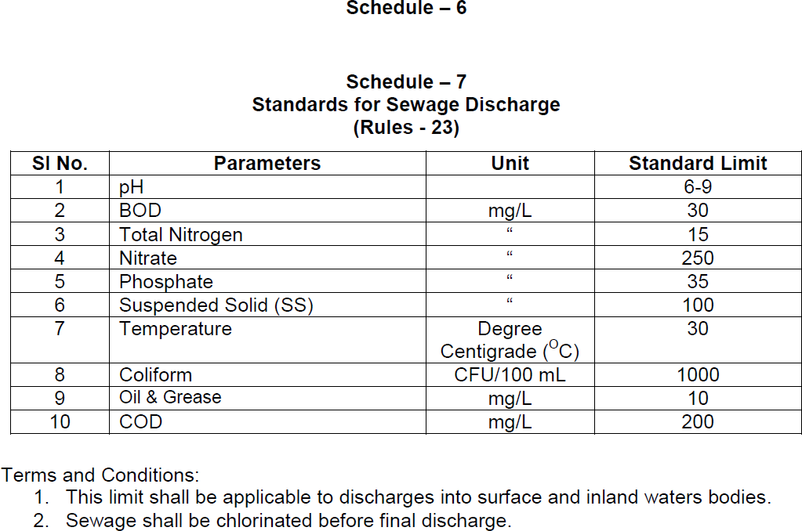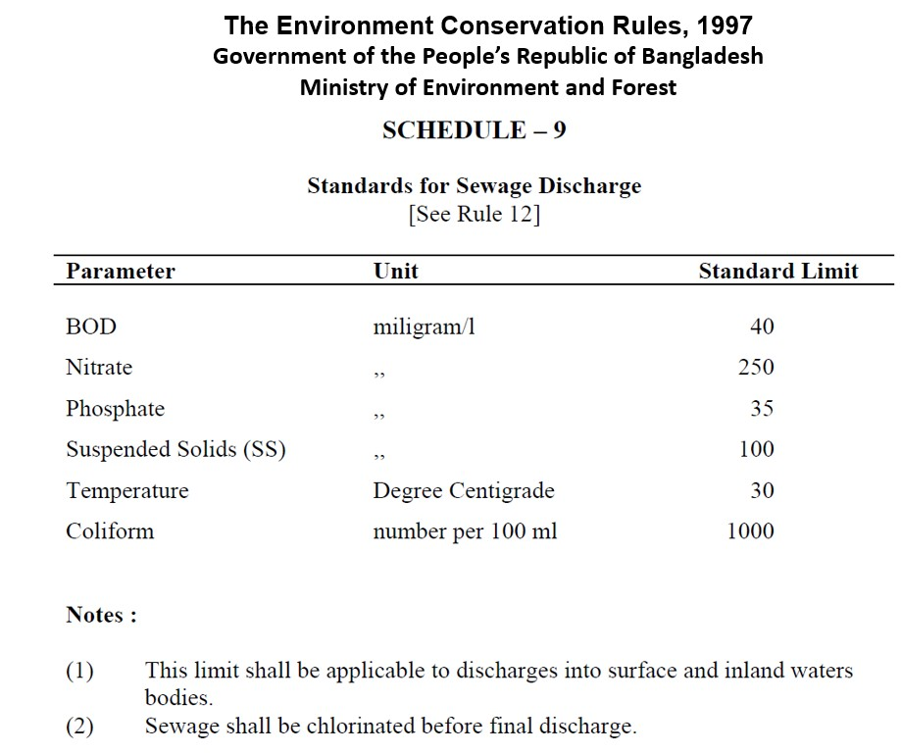

**Figure: Updated DoE guidelines (to become operational early 2019)**

# Appendix B:

Mandatory minimal **Personal Protective Equipment (PPE**) for everyone handling fecal sludge



**Hand Gloves Safety Goggles Full Body Protective Clothing**



**Gumboots Face Mask**

**Safety Helmet**