**DSK-unicef WASH Project, Cox’s Bazar.**

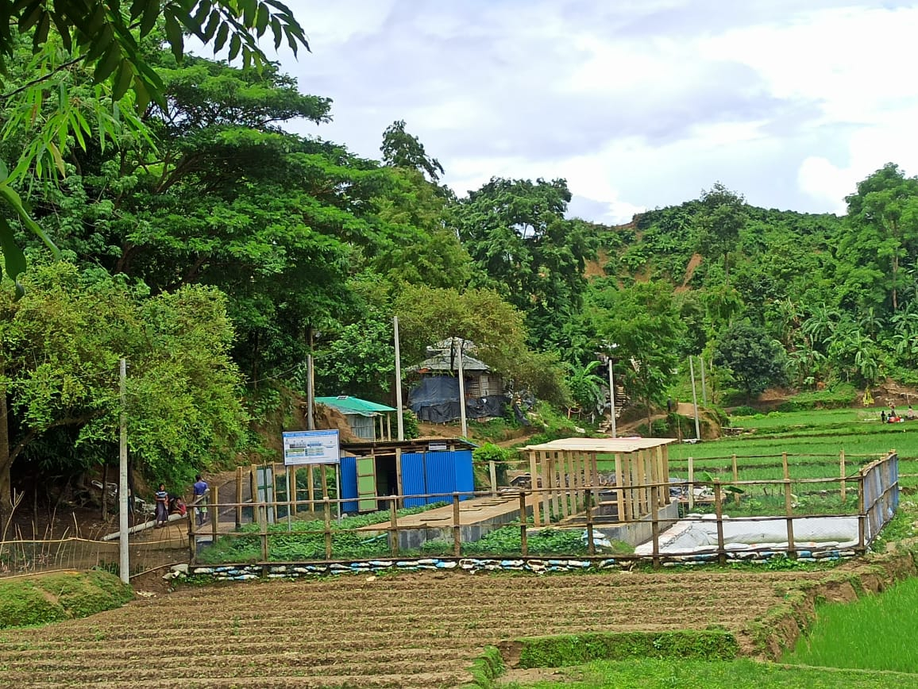

**FSM_Anaerobic Baffled Reactor (ABR)**

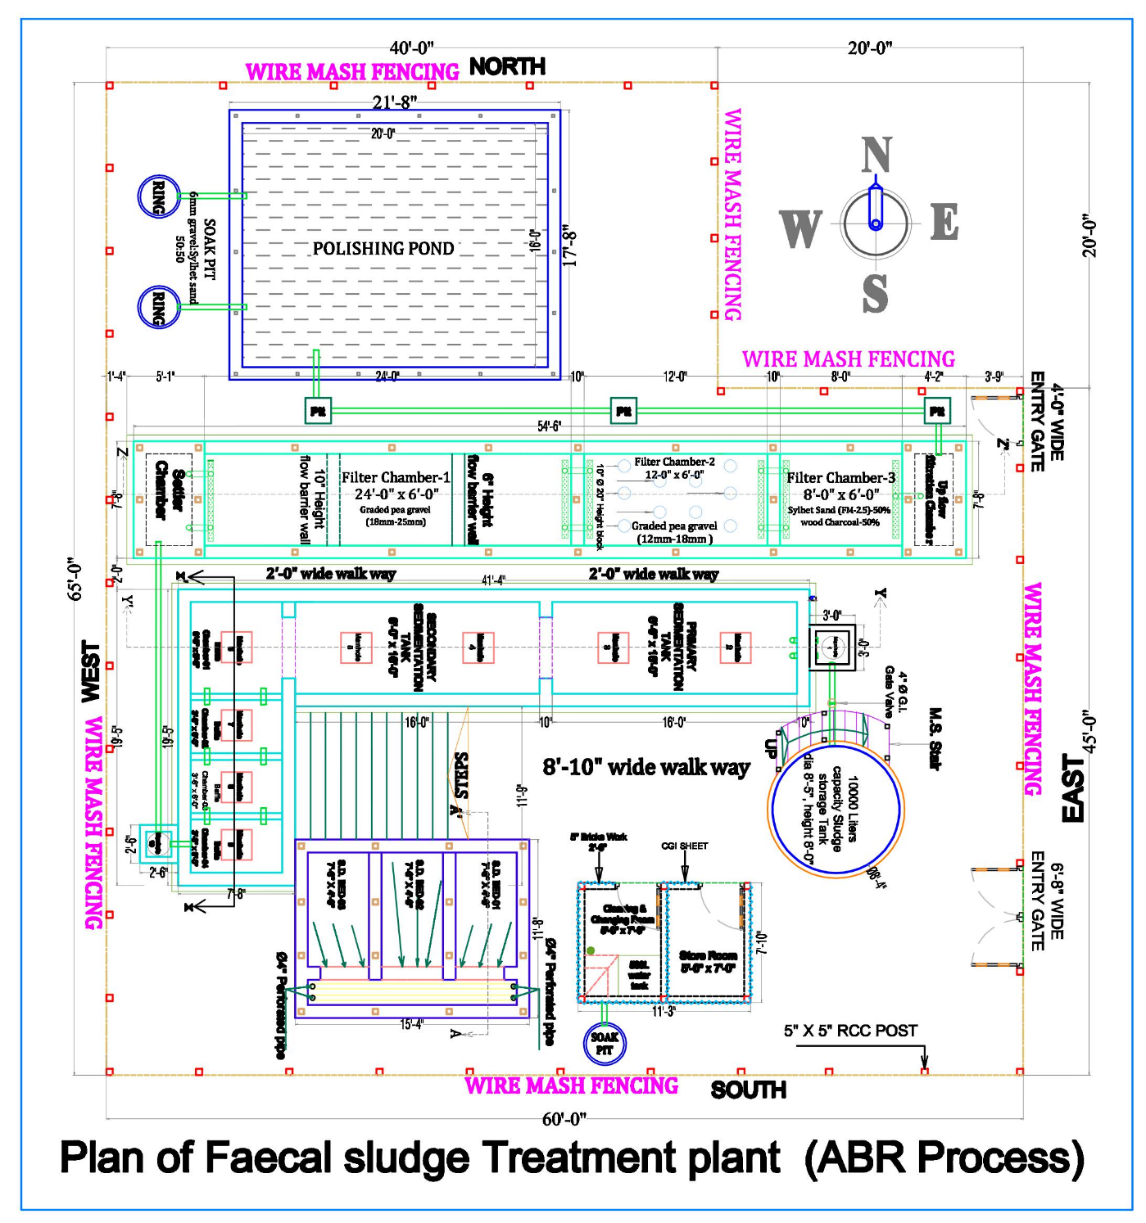

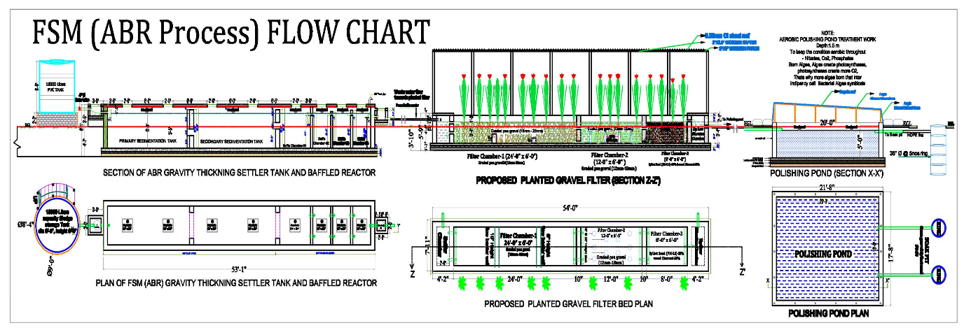

**Objectives, Guiding principles, Flow Chart, User Guidelines & Carefulness.**

# **Introduction:**

Since 2017, **Dushtha Shasthya Kendra (DSK)** has successfully providing lifesaving WASH services in camp 22 (Unchiprang) with the support of UNICEF as a WASH expert agency interaction with other humanitarian organizations and camp management for coordinated and consolidated WASH actions to improve accessibility of Water, Sanitation, and Hygiene Promotion activities. In these camp, 4411 HH 23015 beneficiaries is enjoying 1434 of Hygienic latrines, regular sludge desludging, upgradation or decommissioning of those latrines need FSM interventions for manage faecal sludge.

# **Objective:**

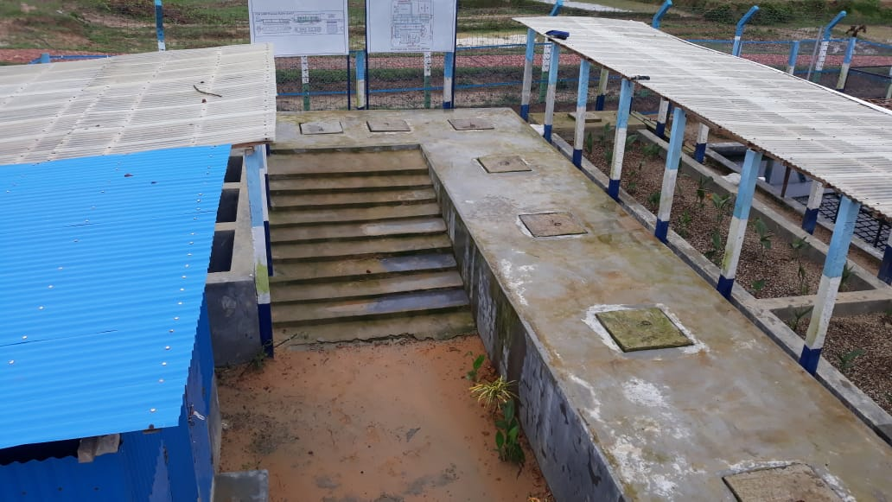The objective of FSM in the camps is to sustain and protect public health by minimizing faecal disease transmission. Faecal disease transmission should be diminished through minimizing direct exposure to faecal sludge, minimizing the impact of disease spreading vectors, and minimizing the contamination of the environment.

The final objective of any FSM intervention should be to meet national effluent standards (Standards for Sewage Discharge - The Environment Conservation Rules, 1997, Government of the People's Republic of Bangladesh, Ministry of Environment and Forest) and Bangladesh Standards and Guidelines for Sludge Management ( Feb 2015). The national effluent standards can be found in **appendix A**. In 2017, the DoE has revised the standards the new standards will come into effect in 2019, which are also shown in **appendix B**.

# **Guiding Principles:**

To achieve the objective, only full-chain FSM approaches need to be implemented. A full-chain FSM approach follows the following key principles **(WASH Sector, Cox’s Bazar):**

* Untreated faecal sludge is separated from people, food, vectors and surface water sources.
* All sections of the community have access to safe, culturally acceptable and hygienic latrines. Operation & maintenance should be ensured by community engagement.
* Latrine designs should meet **RRRC (**Refugee Relief and Repatriation Commissioner) approved designs and minimise the need for sludge handling i.e. emptying.
* Direct contact with faecal sludge is prevented by assuring the regular emptying of full pits.
* Faecal sludge is transported in a way that minimizes direct contact and spillage. Mechanical transport systems need to be implemented rather than manual transport.
* Faecal sludge is treated and discharged in a way that minimizes the direct human exposure to it, minimizing the impact of disease spreading vectors and minimizing the contamination of surface water bodies
* Everybody that handles faecal sludge is protected through the use of proper protective equipment to protect their health and safety and has access to cleaning and disinfection facilities.
* When possible, it is preferred to use treated sludge for agriculture (not possible for lime treated sludge), filling material or as a resource for bricks.

# **Flowchart:**



# 

**Co-Composting**

# **User Guidelines:**

1. 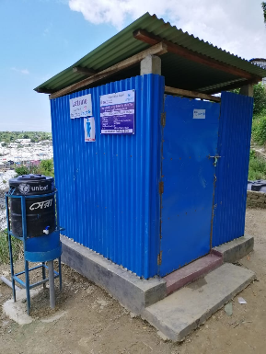**User Interface:** All latrines should be constructed in accordance with the RRRC and WASH Sector, Cox’s bazar agreed latrine designs.
2. 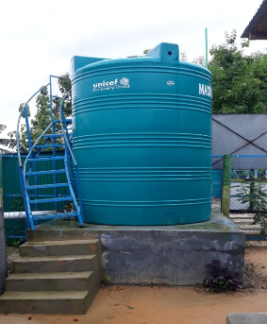**Storage Tank:** To maintain per day **(24 Hours) 8000 litres** waste water flow, need to installed 10000 litres capacity of sludge storage tank to storage sludge and should adjust Gate valve max peak flow per hour 333 Litters or per minute 5.56 Litters, and need to installed a stair to rise above the tank to complete the desludge operation safely .
3. 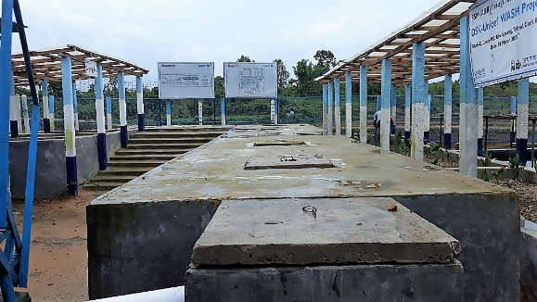**Sedimentation Chambers**: Sedimentation is the processes of letting suspended material settle by gravity. Sedimentation is accomplished by decreasing the velocity of the water to a point which the particles will no longer remain in suspension. When to desludge, an inspection for sludge layer thickness can determine whether desludging is required. It is recommended that a sedimentation tank must be pumped out

• When sludge and scum occupy half to two-thirds of the tank’s working capacity (the tank volume below the outlet pipe invert level).

• To smooth functionality every 6 months interval sedimentation tank need to desludge.

1. 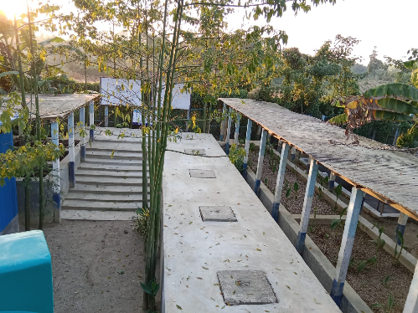**Baffle Chambers:** [Anaerobic](https://sswm.info/content/anaerobic) baffled reactors (ABR) that have been upgraded with a series of baffles along the treatment chamber. The up flow chambers provide enhanced removal and digestion of organic matter. ABRs are based on a physical treatment (settling) and a biological treatment ([**anaerobic digestion**](https://sswm.info/arctic-wash/module-4-technology/further-resources-wastewater-treatment/anaerobic-digestion-%28general%29)). Baffles under which the wastewater is forced to flow. The increased contact time with the active biomass (sludge) results in improved treatment**.** When to desludge, an inspection for sludge layer thickness can determine whether desludging is required. It is recommended that a Baffle tank must be pumped out

• If the bottom of the scum mat is less than 8 Centimetres (cm) above the bottom of the baffle/outlet pipe.

• If the minimum working capacity is reached, to smooth functionality every 6 months interval baffle chambers also need to desludge.

1. 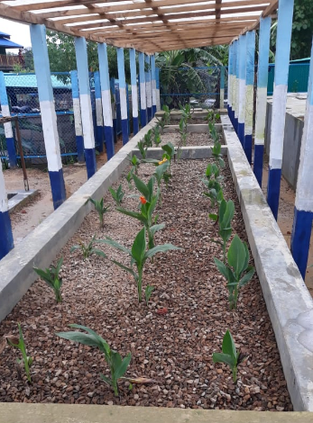**Filter Media**: Graded filter materials are placed inside of the each chamber, having **Canna Indica** plants over the bed to absorb pollutants naturally. When planting canna indica bulbs, plant taller varieties 2′ feet apart. Plant dwarf varieties 1′ foot apart and 4″ inches deep in the bed for enough space to grow. For greatest number of blooms and dark green bright leaves, Canna indica need to get lots of suns.

To improve filtering capacity every 12 months interval, 1st & 2nd chamber stone chips need to wash perfectly & reuse, also 3rd chamber course sand need to change. In this washed period Canna Indica plants planting in pots or containers, fill them with a high quality well-drained soil. Container plants may need to be water twice per day during hot summers, after successfully replaced filter materials re-plantation Canna Indica over the bed is just the same as discussed.

1. 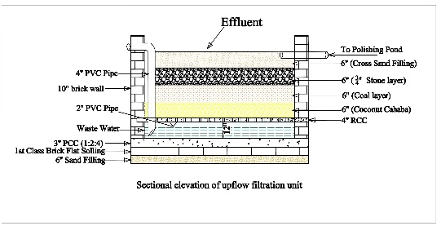**Up flow filtration chamber**: Up-Flow filter has several removal mechanisms: sedimentation and filtration, sorption, and ion exchange. Waste water is treated through 3 layers of filter media; remove fine total suspended solids (TSS), metals, nutrients and bacteria. To improve filtering capacity, up-flow filtration chamber materials also need to change every 12 months interval.
2. 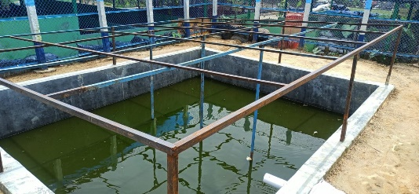**Polishing Pond:** Depends on the Polishing pond capacity, faecal sludge treatment sites which address the full-chain treatment processes are allowed to **discharge the liquid effluent to open water bodies** when national guidelines are met. If national guidelines are not met, the liquid effluent should be **infiltrated**.
3. 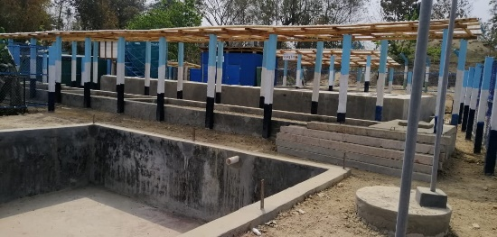**Soak Pit:** The bottom of the infiltration ditch/soak pit is at least 1.50 m above the highest groundwater table in relatively fine soils. In coarser soils, this distance should be increased.
4. 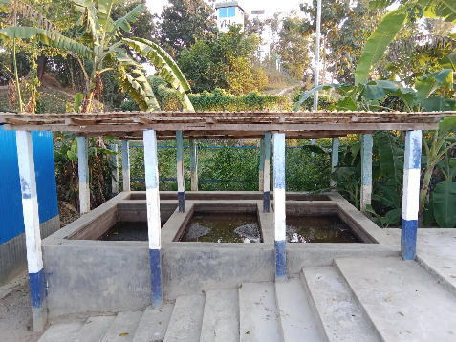**Sludge Drying Bed:** Collecting retain sludge from sedimentation chambers & Baffle chambers, let the sludge drying in the infiltration bed minimum 21 days, after that use drying sludge for co-composting ratio is 1:4. After produce final product, manure quality is assured as per government requirements if the standard met the manure requirement this batch manure use as a cultivation fertilizer within the camp home base plantation, gardening & farmers if they are willingly interested to use (not possible for lime treated sludge), if the standard not met the manure standard parameters then use as filling material or as a resource for bricks.
5. 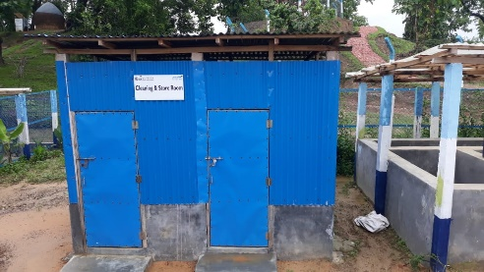 **Cleaning & Store room:** Adequate provision of water is provided for hygienic cleaning of desludging workers after completion of daily operations so that they can carry out their cleaning duties and storage facilities is added to store necessary cleaning equipment’s for carrying out daily desludging operations.

# **Carefulness:**

1. All faecal sludge treatment sites should be properly separated from the general population.
2. Faecal sludge treatment sites must be protected against flooding. Flood prone sites are not suitable for faecal sludge treatment.
3. The distance of the faecal sludge treatment site is at least 30 meter away from water wells (Sphere standards, 2018).
4. Workers involved in the emptying, transport, treatment or disposal of FS need to be provided with adequate PPEs, bathing and laundry soaps and follow protocols to protect their health and safety. Protocols should include the putting on and off of protective gear, as well as the cleaning of the PPEs. The supply of PPEs and the education of the FSM workers is the sole responsibility of the implementation actor (**shown in appendix C)**.
5. Sludge Treatment site should have facilities for hand washing and bathing. Agencies should provide soap.
6. All staff and community volunteers who are working with faecal sludge or at the faecal sludge treatment site should be vaccinated against tetanus and cholera and if possible also typhoid, Hepatitis A and B.

# **Appendix A:**

# **Appendix B:**

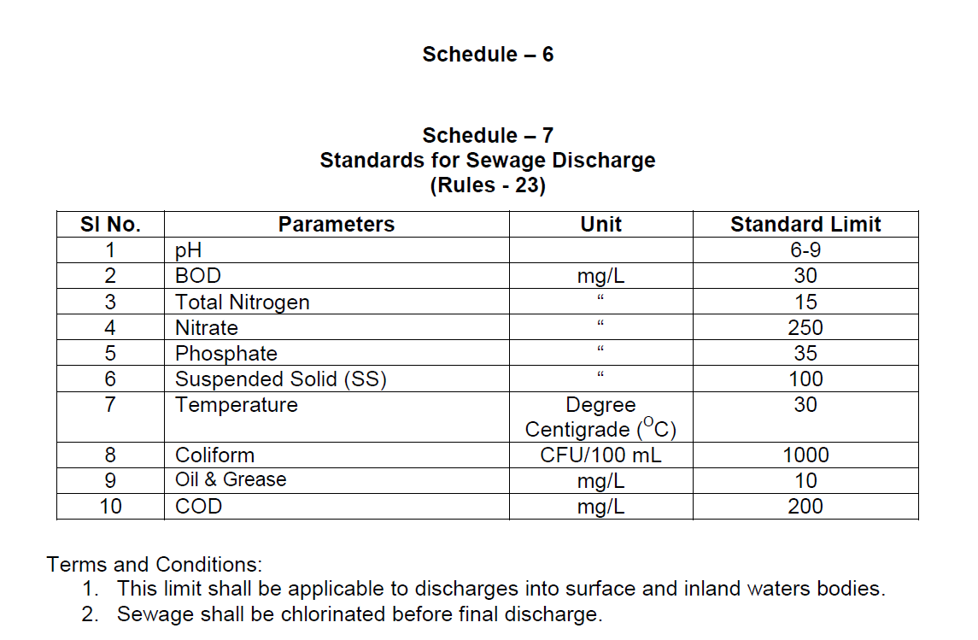Updated DoE guidelines (to become operational early 2019)

# **Appendix C:**

Minimal Personal Protective Equipment for everyone handling faecal sludge

•Gloves •Goggles •Full body protective clothing

•Gum boots• Cap •Face mask (for those handling fresh sludge).





Prepared by

Md. Enam Siddique

Experts (Water & Sanitation).