***KTP FSTP DRAINAGE LAYOUT***

***Brief***

*UNHCR -OXFAM and MSF is constructing a Centralized Fecal Sludge Treatment Plant with 180 m3 capacity / day. For effective storm water drainage and final effluent discharge, this plant need a proper drainage system. Below sections are documented for explaining the drainage layout and requirement to use the existing drain of DRC compound jointly for the site.*

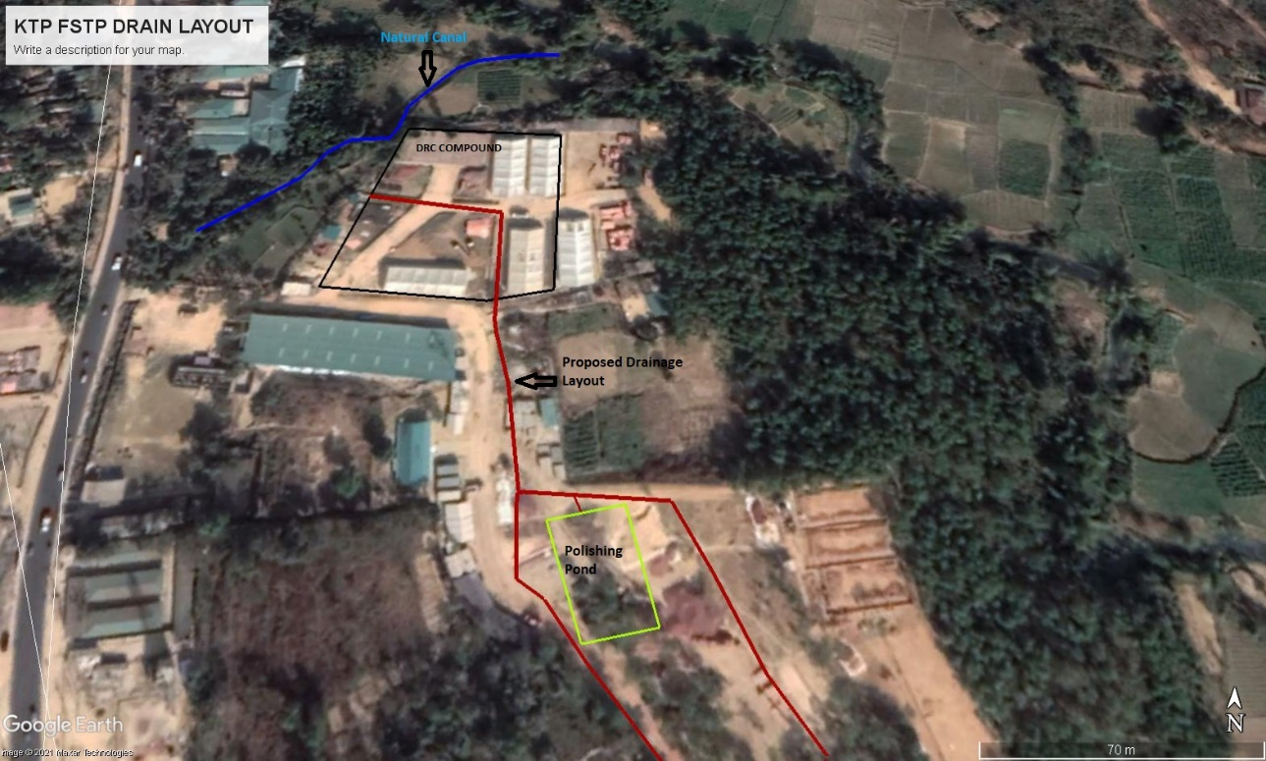

Figure : Proposed Route for surface drainage at KTP FSTP

Following The design calculation, total area has been divided into following three section of drains

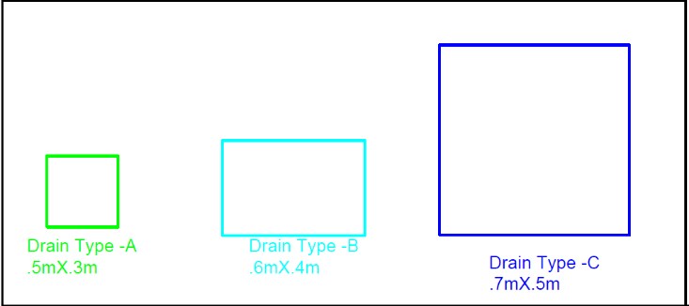

Figure : Different Cross section of drains , Inside the DRC compound drain section will follow the existing excavated portion

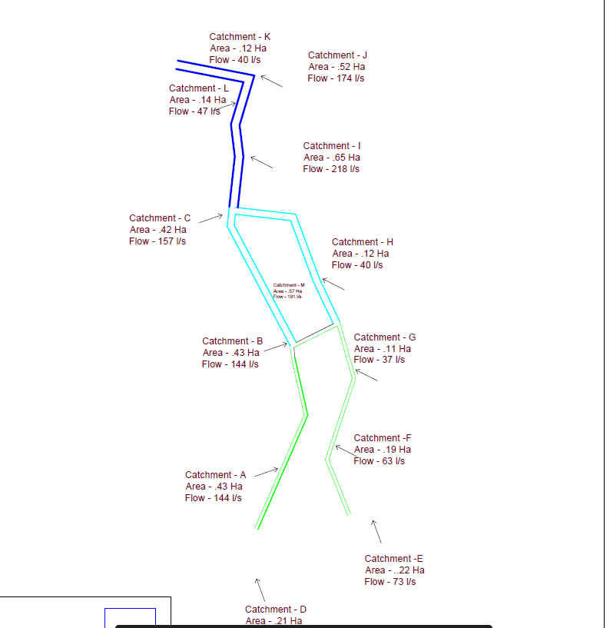

Figure : Layout of Type A , B and C drain

**Accessing DRC Compound**

The natural contour and drainage is going through the DRC compound where there is existing earther drain ( Figure )

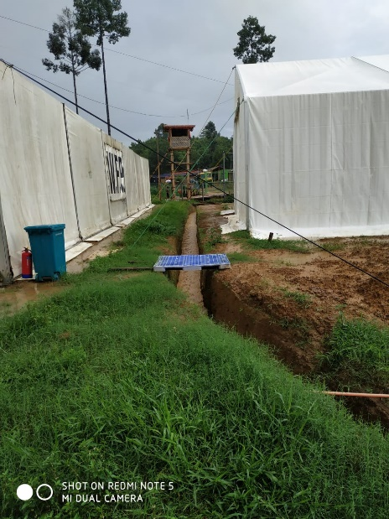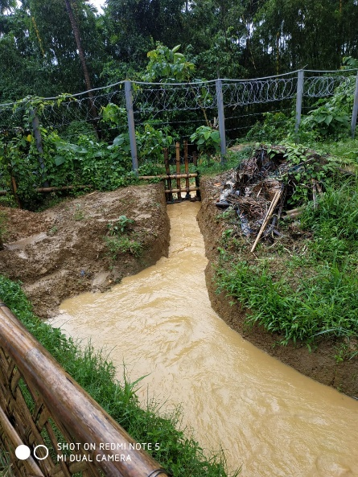

UNHCR and OXFAM team did a visit to the site on 20th June ,2021 and had a discussion with the responsible DRC person. Initially they have mentioned that, there is no plan to do civil construction work at the existing drain inside DRC compound.

**OXFAM proposition**

1. OXFAM will do the civil construction work of the drain inside the DRC compound following current drain route.
2. All the surface runoff of KTP FSTP catchment and final effluent of the FSTP to be connected with this drain.
3. OXFAM will construct cover slab for the drains inside the DRC site as per requirement.

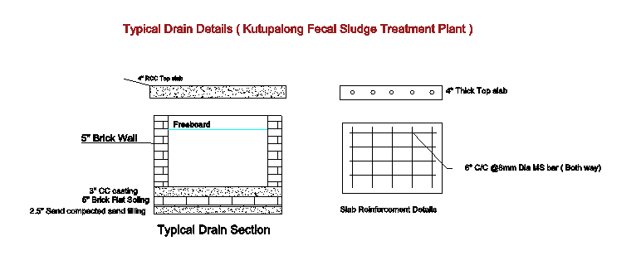

***ANNEX - Drainage Design Calculation***

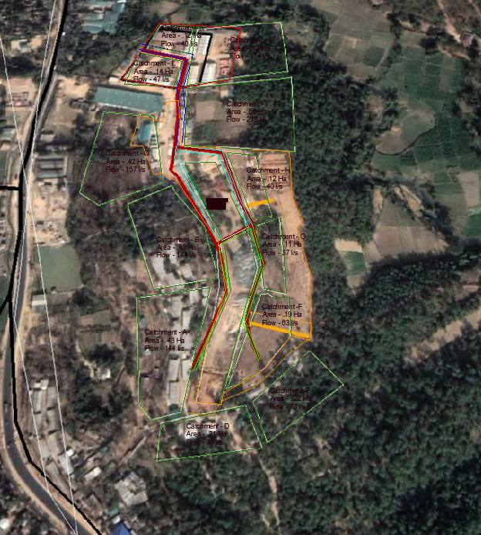

**Surface of the terrain / determination of runoff coefficient –**

Runoff coefficient of .6 was selected as forest and pastures with gradient >.05

**Determination of rainfall intensity**

**As no local IDF ( Intensity -Duration – Frequency curve was not available.**

MAX rainfall intensity of 200mm/ Hr has been calculated for Kutupalong , Ukhiya.

Amount of water the catchment will produce –

**Qdesign = 2.8XCXiXA**

Qdesign= The design peak runoff rate, or the maximum flow of storm water the system will be designed for ( In litres per second )

C= The runoff coefficient

I = The rainfall intensity at the time of concentration read from the chosen IDF curve / Average value in mm/h

A= The surface area of the catchment area in ha

Drain Sizing

Q= 1000 X ( A X (R).67 X (S).5 / N)

Q= The capacity of discharge of the drain ( l/s )

A= The cross section of the flow ( in m2 )

R = The hydraulic radius of the drain ( Cross sectional area / Total length of contact between water and drain )

S= The gradient of the drain

N = Manning’s roughness coefficient ( for brick drain .025 ) – Check )

Take 20% Safety Factor ( For solid deposition , Satellite variation , lack of maintenance etc.

|  |  |  |  |  |  |  |
| --- | --- | --- | --- | --- | --- | --- |
|  | **Width** | **Height** | **Area** | **R^.67** | **S^.5** | **Q trialed** |
| **C** | 0.7 | 0.5 | 0.35 | 0.346837 | 0.125656 | 610.1501 |
| **B** | 0.6 | 0.4 | 0.24 | 0.306786 | 0.125656 | 370.0759 |
| **A** | 0.5 | 0.3 | 0.15 | 0.263177 | 0.125656 | 198.4189 |

|  |  |  |  |  |  |  |  |  |
| --- | --- | --- | --- | --- | --- | --- | --- | --- |
|  |  | **L/s** |  |  |  |  |  | **L/s** |
| **Area** | **Size( Ha )** | **Q designed** | **W** | **H** | **A** | **R^.67** | **S^.5** | **Q trialed** |
| A | 0.43 | 144.48 | 0.6 | 0.6 | 0.36 | 0.340165 | 0.125656 | 615.5118 |
| B | 0.43 | 144.48 | 0.6 | 0.6 | 0.36 | 0.340165 | 0.125656 | 615.5118 |
| C | 0.47 | 157.92 | 0.6 | 0.6 | 0.36 | 0.340165 | 0.125656 | 615.5118 |
| D | 0.21 | 70.56 | 0.6 | 0.6 | 0.36 | 0.340165 | 0.125656 | 615.5118 |
| E | 0.22 | 73.92 | 0.6 | 0.6 | 0.36 | 0.340165 | 0.125656 | 615.5118 |
| F | 0.19 | 63.84 | 0.6 | 0.6 | 0.36 | 0.340165 | 0.125656 | 615.5118 |
| G | 0.11 | 36.96 | 0.6 | 0.6 | 0.36 | 0.340165 | 0.125656 | 615.5118 |
| H | 0.12 | 40.32 | 0.6 | 0.6 | 0.36 | 0.340165 | 0.125656 | 615.5118 |
| I | 0.65 | 218.4 | 0.6 | 0.6 | 0.36 | 0.340165 | 0.125656 | 615.5118 |
| J | 0.52 | 174.72 | 0.6 | 0.6 | 0.36 | 0.340165 | 0.125656 | 615.5118 |
| K | 0.12 | 40.32 | 0.6 | 0.6 | 0.36 | 0.340165 | 0.125656 | 615.5118 |
| L | 0.14 | 47.04 | 0.6 | 0.6 | 0.36 | 0.340165 | 0.125656 | 615.5118 |
| M | 0.57 | 191.52 | 0.6 | 0.6 | 0.36 | 0.340165 | 0.125656 | 615.5118 |
|  | 4.18 | 1404.48 |  |  |  |  |  |  |